Pin tool kit stuff

# As it were….

I have found myself in need of better tooling and reference material for electrical connector servicing. The following should serve as a reference to the tooling Tri-Met has/has previously had and should have. Some tools are cost effective for the floor technician and some are not.

### Description for crimping tools

ITT/Cannon, Veam model– this brand is a circular multi-conductor connector used extensively in T2 and 3 trains here at Tri-Met. This Veam connector line conforms to military spec XXXXX so it has a structured set of tooling standards.

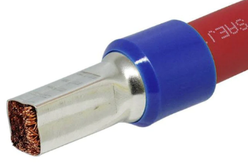Ferrules, ferrules are a conductor sleeve that is crimped in certain ways to accommodate certain connections. I have found this to be very industrial/automation centric.

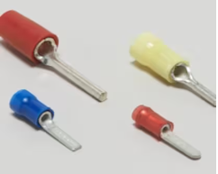TE connectivity/AMP generic PIDG!!! Pre-insulated diamond grip spade crimper is used extensively in T1 and on some places elsewhere in the fleet

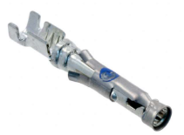TE Connectivity/AMP CPC connectors – These connectors are used extensively in the T1-3 fleet and in some places elsewhere like the TWC connections for the T4-5.

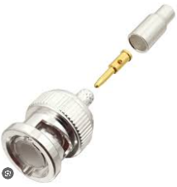Amphenol – BNC connectors. We use coax cables around the fleet for cctv, radio and Wi-Fi antenna connections.

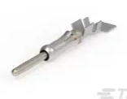Generic crimpers – a lot of terminals we use can be sufficiently crimped with a good quality set of generic W crimpers. There are several different sizes of crimps to be made in this area so it may not be surprising that there are 2-3 sets of crimpers we need to accomplish the range of crimps we have to do.

### Crimping tools

[Crimpin isn’t easy](https://www.te.com/commerce/DocumentDelivery/DDEController?Action=showdoc&DocId=Catalog+Section%7F6-1773984-5%7F2012%7Fpdf%7FEnglish%7FENG_CS_6-1773984-5_2012.pdf%7FN-A) a guide to modern crimping

1. DMC AF8 plus turrets - $500
   1. This one takes turrets and one generic pin stopper
   2. 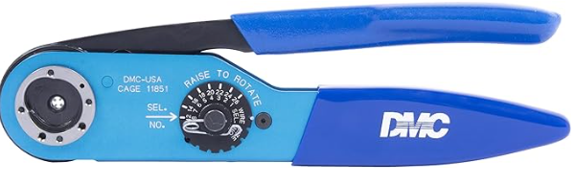
2. DMC AFM 8-smaller one - $450
   1. This one needs specific pin stoppers
   2. 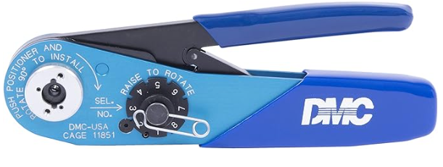
3. Good quality generic W shape crimping tool medium - $50-200 Tri-Met has a few sets of varying quality
   1. 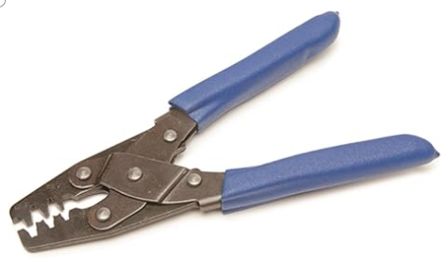
4. Good quality generic small W crimping tool $40 – 120
   1. <https://www.engineertools-jp.com/pa092021>
   2. 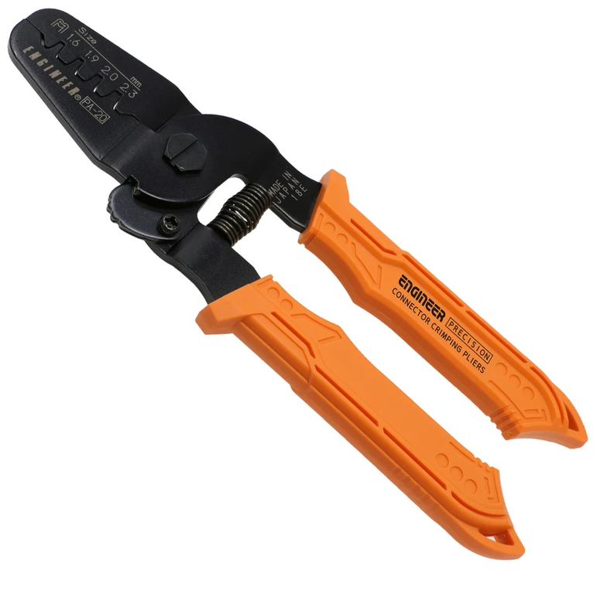
5. Knipex ferrule crimper [97 53 04](https://www.digikey.com/en/products/detail/knipex-tools-lp/97%252053%252004/10451678) $265.00 Tri-Met has a set
   * 1. 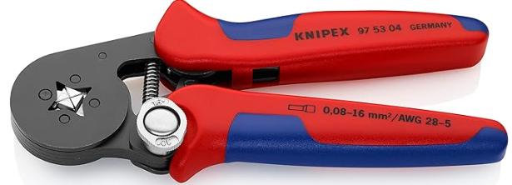
6. Rj45 crmper – klein vdv226-011 $50.00 Tri-Met has a set
   1. 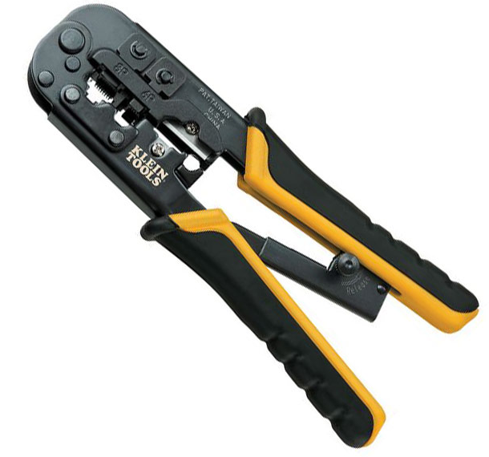
7. Coax crimpers. List link. <https://www.amphenolrf.com/tools/crimp-tools.html>
   1. Normal coax size = .255, FME APC antenna cable = ?.213?
      1. <https://www.amphenolrf.com/ctl-17.html> Tri-Met has.
      2. 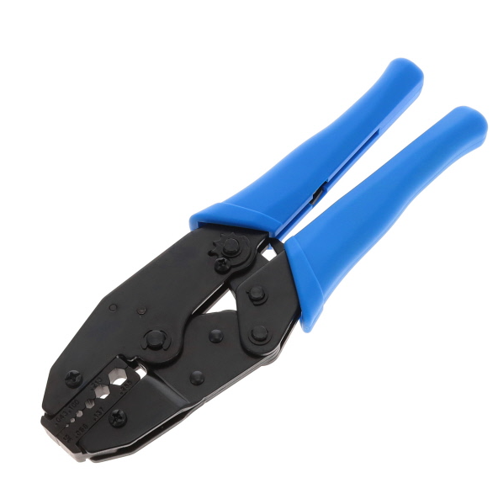
   2. Smaller coax size – see radio and APC Wi-Fi coax size.
      1. <https://www.amphenolrf.com/47-20025.html>
      2. 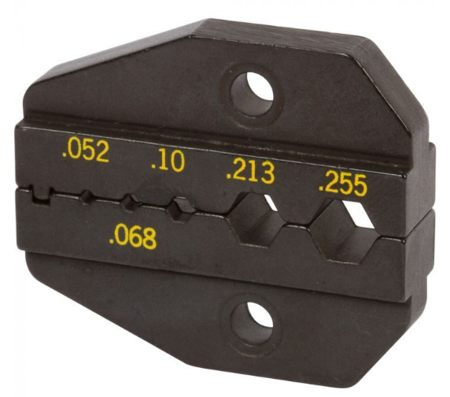
8. Amp [– 59824-1](https://www.digikey.com/en/products/detail/te-application-tooling/59824-1/297746) PIDG terminal crimper $496.24 available in parts dept.
   1. 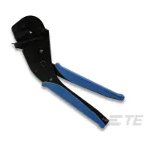
9. Amp/TE connectivity 47386 PIDG (pre-insulated diamond grip)crimper 16-26AWG $953.19 trimet has a set
   1. This works on most generic PIDG terminals but maybe only the red class
   2. 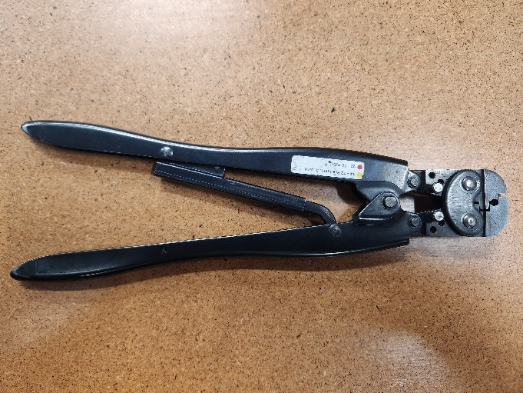
10. AMP/TE Connectivity 59239-4 12-10AWG yellow terminal $1386.09 panto rebuild has a set
    1. 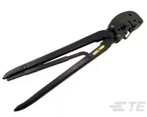
11. AMP/TE Connectivity 47387 20-14 AWG $919.91 Tri-Met has a set
    1. 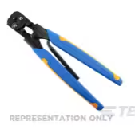
12. Snap on 29ACF $76.25
    1. 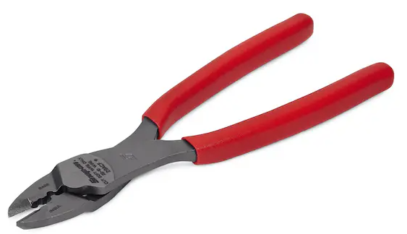
13. TE connectivity crimper body 354940-1 $132
    1. <https://www.digikey.com/en/products/detail/te-application-tooling/354940-1>
       1. This is a crimper with no jaws. The jaws are application specific
    2. 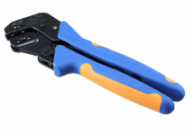
14. Harting 09990000620 $524.48 Tri-Met has one
    1. 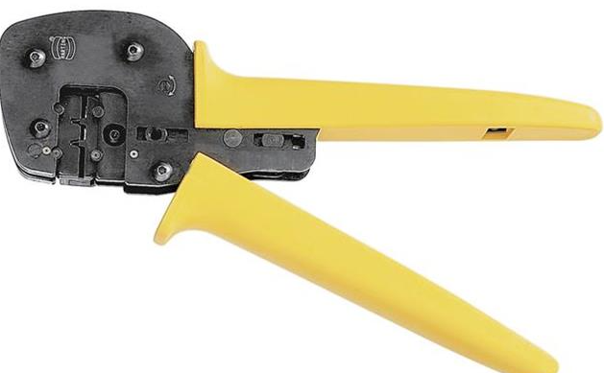
15. Knipex 97 53 08 $256.88 panto rebuild has one
    1. 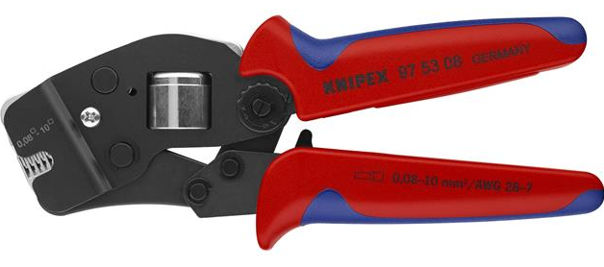
16. Knipex 97 68 145 A $40.00 panto rebuild has one
    1. 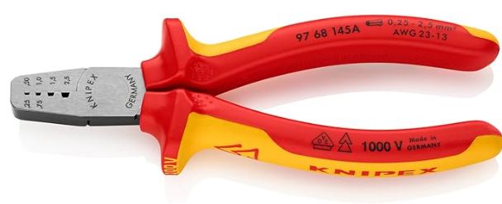

### Description for pin insertion/extraction tools

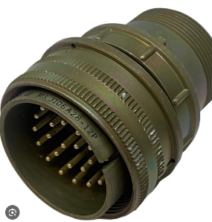Mils spec- Cannon brand Veam model plugs.

These plugs conform to milspec m?????? and will have a fairly preset standard of pinsizes, tools and methods

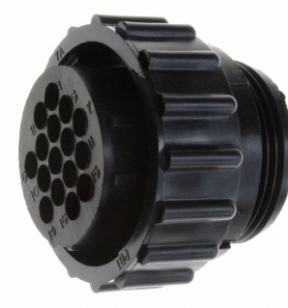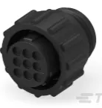TE connectivity/AMP CPC-

These plug family is used extensively in our trains, such as TWC, sutrac hvac, T2-3 carbody …etc

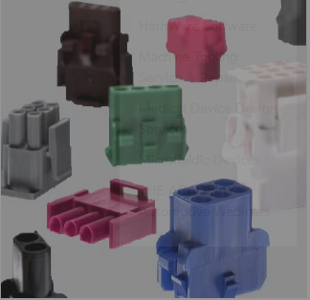TE connectivity mate-n-lok-

While similar to molex I have seen these located all over

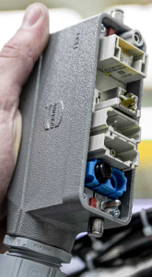

Harting HAN Modular-

I believe that this is the connector standard that is replacing the cannon plugs from here on out. This is a mainstay of automation systems.

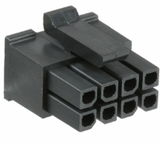Molex – various-

These plugs are usually found in T1-3 CCTV and in hobbyist areas but there is occasionally a reason to repair or replace a plug.

# Pin install/removal tools

### Mils spec/veam plugs

1. Veam A43240 $322.45
   1. [https://www.mouser.com/ProductDetail/ITT-Cannon/A43240](https://www.mouser.com/ProductDetail/ITT-Cannon/A43240%20$322)
   2. 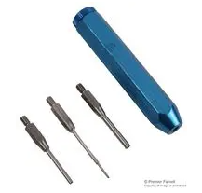
2. Veam 11-7576-37
3. Veam a43240-8
4. DMC pin tool pin 16 -$129
   1. <https://dmctools.com/drk82>
   2. 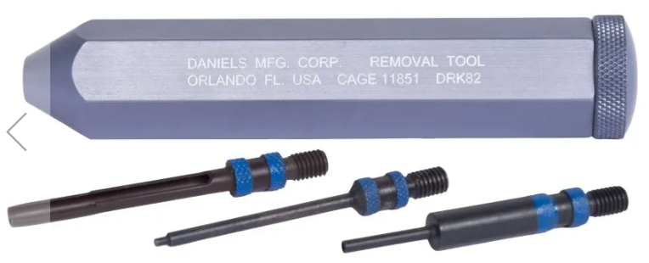
5. DMC pin tool pin 12 - $129
   1. <https://dmctools.com/drk80>
   2. 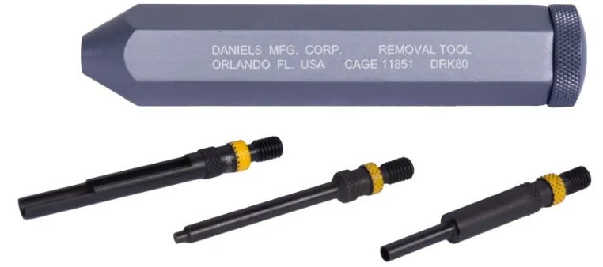
6. DMC pin tool Drk96 – $108.24
   1. <https://dmctools.com/drk96>
   2. 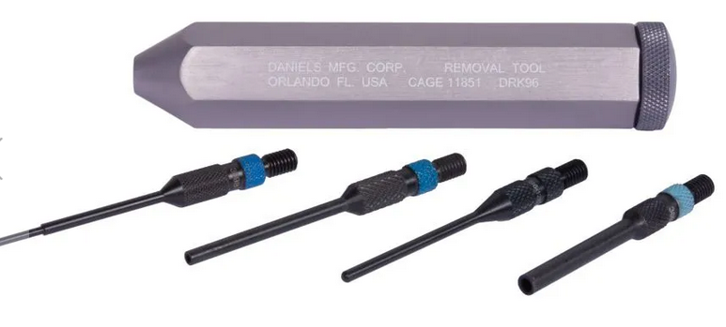
7. Jonard [tools Ka260](https://www.digikey.com/en/products/detail/jonard-tools/KA-260/610384) $175.00 insertion tools
   1. 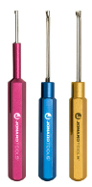
8. [Jonard KR260](https://www.digikey.com/en/products/detail/jonard-tools/KR-260/610385) $175.00 extraction
   1. 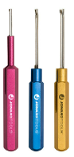

### Fine tip contact tools

1. [TE 91067-2](https://www.digikey.com/en/products/detail/te-connectivity-aerospace-defense-and-marine/91067-2/15557) $18.51
   1. 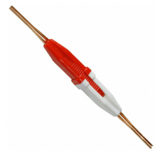
2. TE connectivity [91066-4](https://www.digikey.com/en/products/detail/te-connectivity-aerospace-defense-and-marine/91066-4/298281) $20.71
   1. 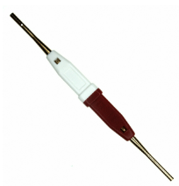
3. TE [91066-3](https://www.digikey.com/en/products/detail/te-connectivity-aerospace-defense-and-marine/91066-3/298280) $20.91
   1. 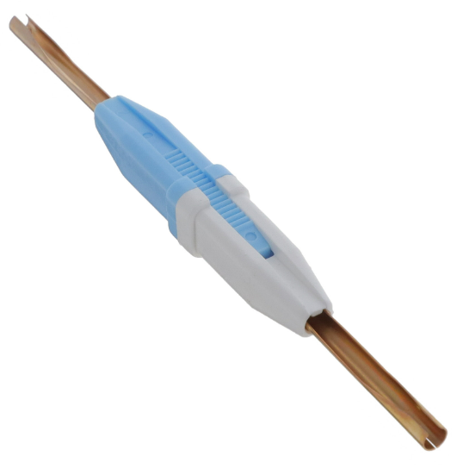
4. TE [91067-1](https://www.digikey.com/en/products/detail/te-connectivity-aerospace-defense-and-marine/91067-1/207259) $18.20
   1. 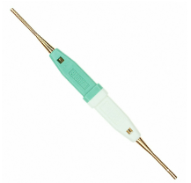
5. TE connectivity [1643915-1](https://www.digikey.com/en/products/detail/te-connectivity-amp-connectors/1643915-1/1636374)  plastic body $5.23
   1. 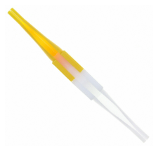
6. Astro tool corp [M81969/14-03](https://www.digikey.com/en/products/detail/astro-tool-corp/M81969-14-03/4951912) pin size 16 $2.65
   1. 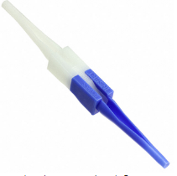
7. Astro tool corp [M81969/14-04](https://www.digikey.com/en/products/detail/astro-tool-corp/M81969-14-04/4951913) $2.65
   1. 

Guide pins DMC- This area is incomplete

1. 27977-16T50 #16 pin size
   1. <https://www.mouser.com/ProductDetail/ITT-Cannon/27977-16T50> $7.10
2. 27977-12T50 #12 pin size

### Harting plugs

1. Han D plug Pin puller tool 09990000328 $112.00
   1. 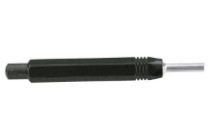
2. Pin puller tool HAN E 09 99000 0319 $40.00
   1. 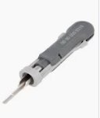
3. 09 99 000 0305 $20.00
   1. 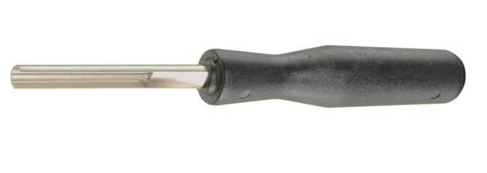
4. 0999 000 0315 $75.00
   1. 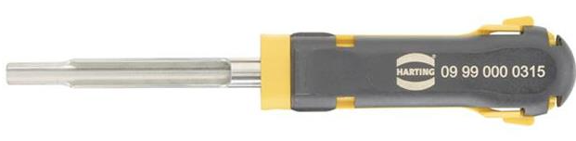
5. 09 99 00 0052 $15.04
   1. 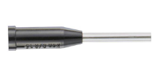
6. HAN d removal tool? 09990000012 $63.04
   1. 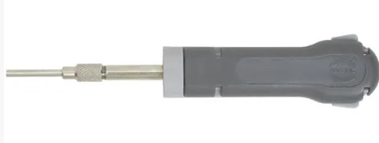
7. socket puller 09 99 000 0828 $179.00
   1. 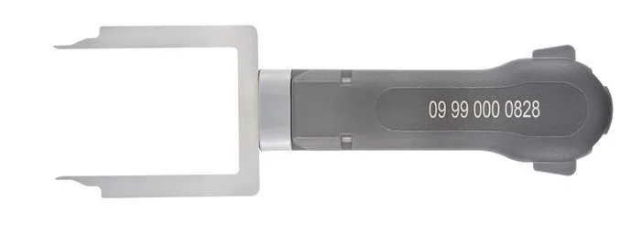
8. Sub D HAN contact removal tool 09990000368 $28.25
   1. <https://www.digikey.com/en/products/detail/harting/09990000368/3181508>
   2. 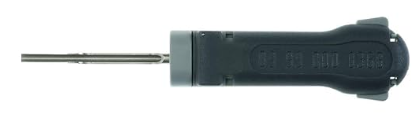

## Molex plugs

1. mini fit jr pin remover 11-03-0044 **$28.54**
   1. 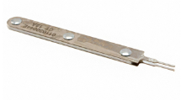
2. Mini fit JRready tool **$25.00**
   1. 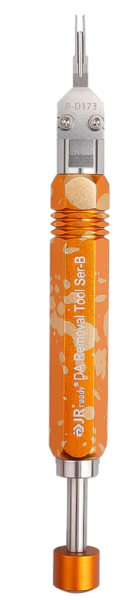
3. 0.084 terminal Molex 0011010168 **$44.43**
   1. 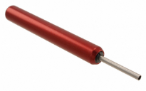
4. [0.093 terminal Molex 0011030006](https://www.digikey.com/en/products/detail/molex/0011030006/228692) **$28.54**
   1. 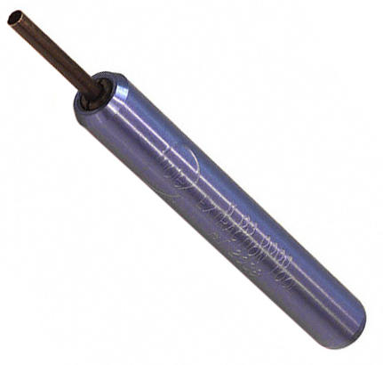
5. 0.062 Terminal Molex **$24.96**
   1. 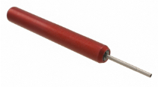
6. TE Connectivity/AMP D-sub? Tri-Met has previously had this tool.
   1. TE-91285-1 $ 40.00
      1. 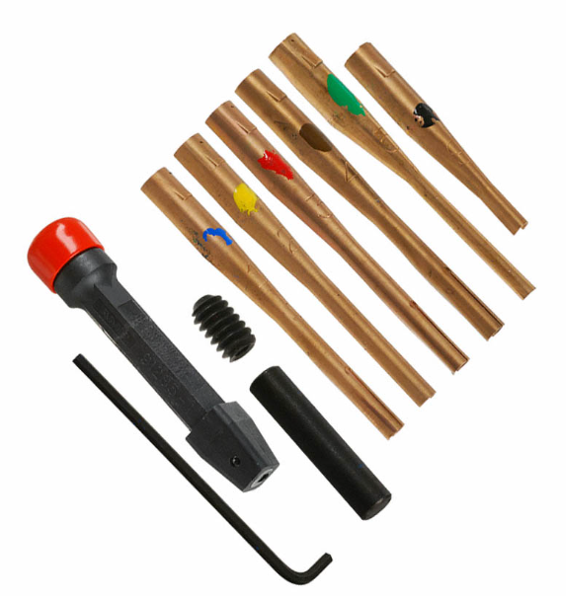

### TE Connectivity Mate-n-lok

1. <https://www.te.com/usa-en/product-465644-1.html> **$42.00**
   1. 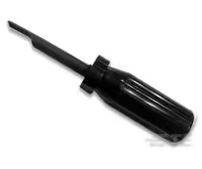
2. [https://www.digikey.com/en/products/detail/te-application-tooling/465644-1/15682](https://www.digikey.com/en/products/detail/te-application-tooling/465644-1/15682%2039.00) **$39.00**
   1. 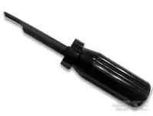
3. <https://www.digikey.com/en/products/detail/te-application-tooling/1-305183-1/1990885> **$279.00**
   1. 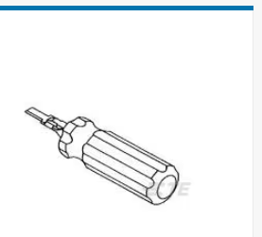
4. TE connectivity Mate-N-Lok extract 1-305183-1 **$279.00**
   1. 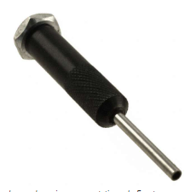
5. TE Connectivity mate-n-lok socket extract **189727-1 $33.00**
   1. <https://www.te.com/usa-en/product-189727-1.html>
   2. 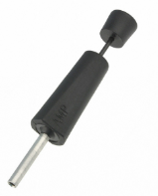
6. Universal Mate-n-lok tool **9-1579007-5 $79.00**
   1. 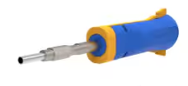

### TE Connectivity/AMP CPC (circular plastic connector)

1. removal tools TE-305183 **$17.46**
   1. <https://www.digikey.com/en/products/detail/te-application-tooling/305183/15640>
      1. 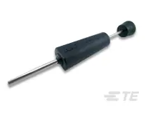
2. Removal tool TE 2063388-1 **$19.00**
   1. <https://www.te.com/usa-en/product-2063388-1.html> 19.00
      1. 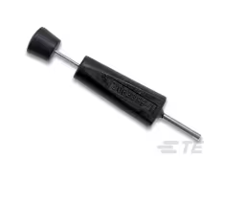
3. Insertion extraction 91285-1 **$40.00**
   1. <https://www.te.com/usa-en/product-91285-1.html> **$39.00**
   2. <https://www.digikey.com/en/products/detail/te-application-tooling/91285-1/132443> **$33.00**
      1. 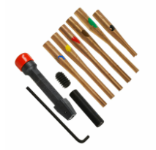
4. TE connectivity [9-1579007-1](https://www.digikey.com/en/products/detail/te-application-tooling/9-1579007-1/2053544) **$65.00**
   1. 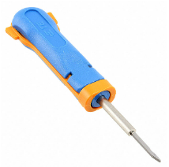

## Plastic contact tools

These tools are speculative right now as I think they will help with cannon plugs. They have not been tested.

1. TE Connectivity [114010](https://www.digikey.com/en/products/detail/te-application-tooling/114010-ZZ/6566678) **~$2.00**
   1. 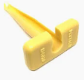
2. TE Connectivity [0411-337-1205](https://www.digikey.com/en/products/detail/te-application-tooling/0411-337-1205/9477715)  **~$2.00** EA
   1. 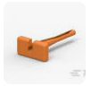
3. TE Connectivity 0411-204-1605 **~$2.00** EA
   1. 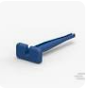
4. TE Connectivity 0411-291-1405 **~$2.00** EA
   1. 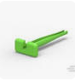
5. TE Connectivity [0411-310-1605](https://www.digikey.com/en/products/detail/te-application-tooling/0411-310-1605/9477714)  **~$2.00** EA
   1. 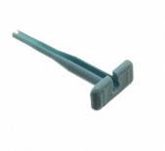
6. TE Connectivity [0411-336-1605](https://www.digikey.com/en/products/detail/te-application-tooling/0411-336-1605/6566673)  **~$2.00** EA
   1. 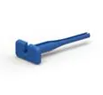
7. TE Connectivity 0411-240-2005  **~$2.00** EA
   1. 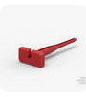
8. TE Connectivity [0411-354-1605](https://www.digikey.com/en/products/detail/te-application-tooling/0411-354-1605/9477716) **~$3.50** EA
   1. 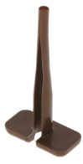
9. Amphenol sine [AT11-337-1205](https://www.digikey.com/en/products/detail/amphenol-sine-systems-corp/AT11-337-1205/14011232) **$1.44**
   1. 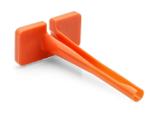

### Pin install plyers

1. Veam install plyers **$100.00** 11-7345 size 16 pin
   1. <https://www.mouser.com/ProductDetail/ITT-Cannon/11-7345>
   2. 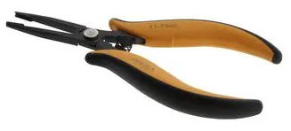
2. Veam install plyers p46736 size 12 pin
   1. <https://www.newark.com/veam/46736/insertion-tool-size-12-contact/dp/51M8181> **$245**
   2. 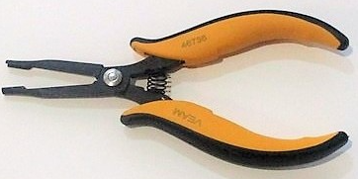
3. DMC install plyers DAK-168-16 pin size 16
   1. <https://dmctools.com/dak489> **340.13**
   2. 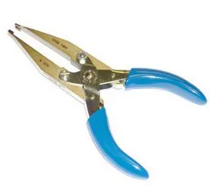
4. DMC install pliars DAK168-12 pin size 12
   1. <https://dmctools.com/dak168-12> **$332.34**
   2. 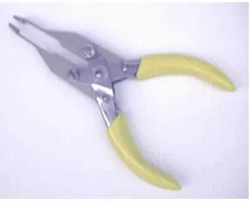
5. TE connectivity [91002-1](https://www.digikey.com/en/products/detail/te-connectivity-amp-connectors/91002-1/29746)   
   TOOL INSERTION .062 & .093 CONN
   1. 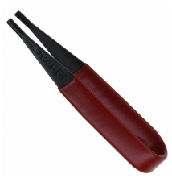

## The great unknown – why we need generic pin tools.

Jr ready kits for unknown and unexpected situations. Add purchase links

1. Jready st5211 **$22.00**
   1. 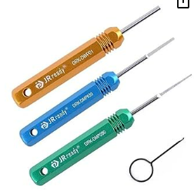
2. Jready st 5252 **$40.00**
   1. 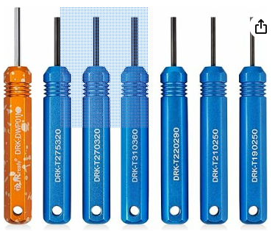
3. Jready st5236 **$50.00**
   1. 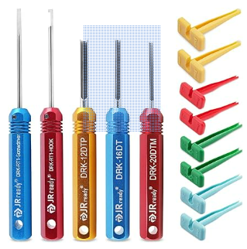
4. Jready st 5227 **$50.00**
   1. 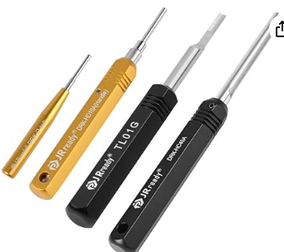

### Wire stripping tools

1. Ideal brand stripmaster
   1. Goto site to find which one you want!
   2. 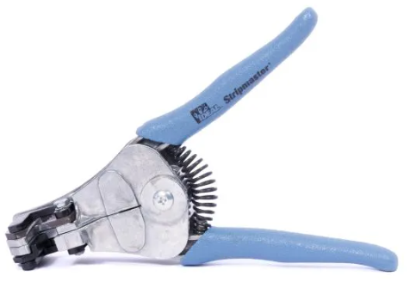
   3. <https://www.idealind.com/us/en/shop/product-type/aerospace/stripmasterr.html>
   4. 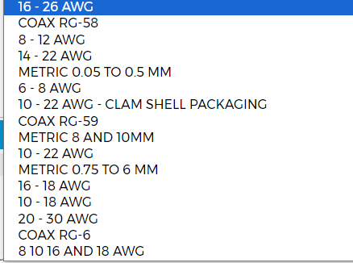
2. Various gauged strippers
   1. Snap on PWCS7ACF **$60.00**
      1. 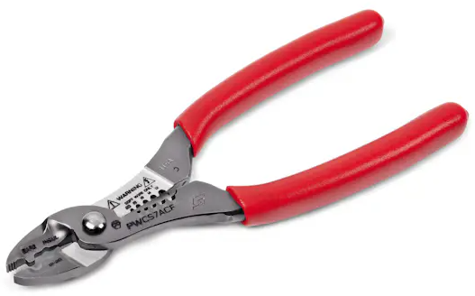
   2. Snap on 9 inch stripper [pwcs9acf](i.%09https:/shop.snapon.com/product/Strippers-Cutters%2FCrimpers/9%22-Wire-Stripper-Cutter%2FCrimper%2FBolt-Cutter-(Red)/PWCS9ACF) **$67.00**
      1. 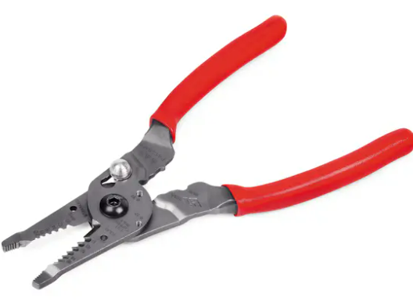
   3. Engineer wire stripper
      1. <https://www.engineertools-jp.com/pa05060714>
      2. 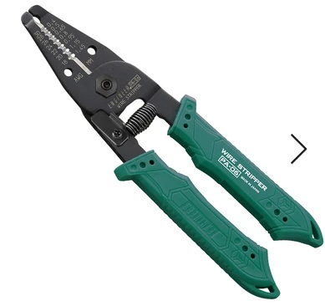
3. Coax stripping tools
   1. Ideal 2 blade adjustable 45-526 1/4 in. strip between blades
      1. 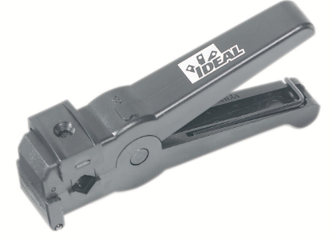
   2. Ideal3 blade adjustable 45-520
      1. 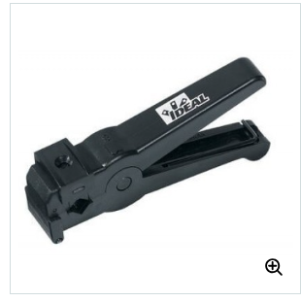
   3. Ideal 45-605
      1. 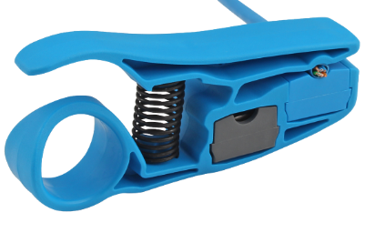
   4. Ideal 45-165
      1. .240”/6.1mm blade spacing, strips from  from .187”/4.8mm up to .313”/8mm in diameter
      2. 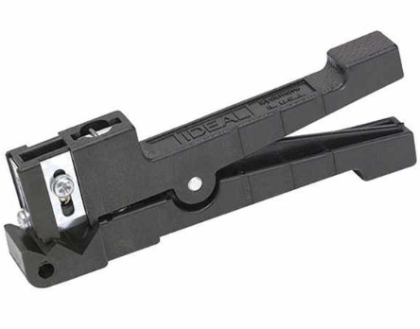
   5. Ideal 45-162
      1. 240”/6.1mm blade spacing, Strips up to .125”/3.2mm in diameter
      2. 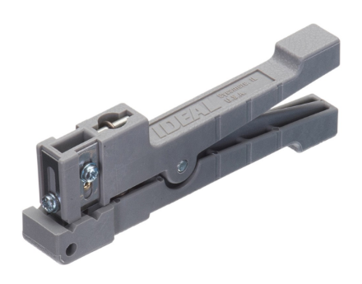
   6. Ideal 45-164
      1. .560”/14.22mm blade spacing, Strips from .250”/6.4mm up to .563”/14.3mm in diameter
      2. 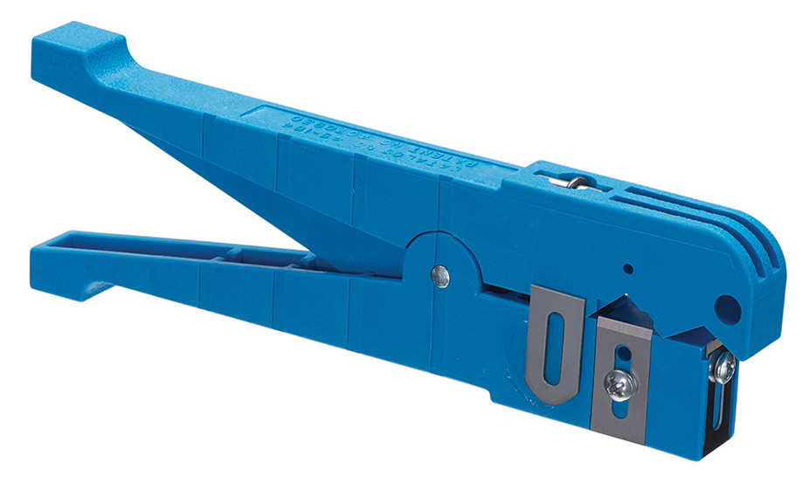
   7. Ideal 45-163
      1. .240”/6.1mm blade spacing, Strips from .125”/3.2mm up to .250”/6.4mm in diameter
      2. 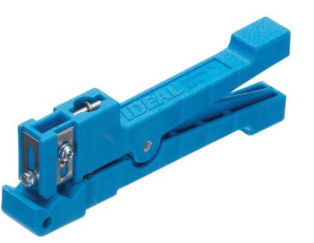

# Bonus round!!!

### Cannon plug plyers.

1. Snap-on [AT1508KG](https://b2b.snapon.com/productDetails/859738/2/882280) **$45.05**
   1. 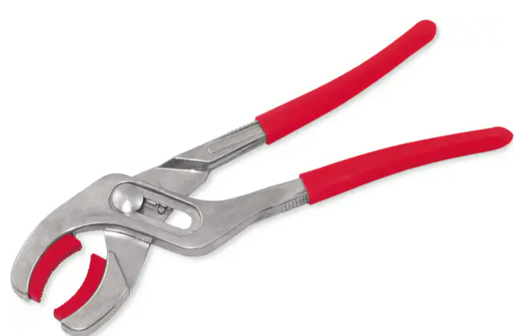
2. Snap-on [pwc53](https://b2b.snapon.com/productDetails/954287/2/882280) **$93.00**
   1. 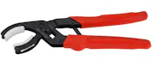
3. Snap-on [pwc5330](https://b2b.snapon.com/productDetails/954295/2/882280) **$93.00**
   1. 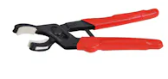
4. Blue point [PWC52A](https://shop.snapon.com/product/Miscellaneous/Connector-Pliers-(Blue-Point)/PWC52A) **$66.00**
   1. 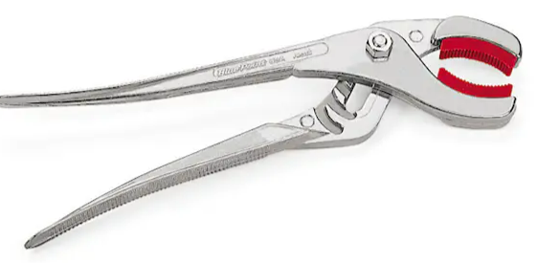
5. Daniels 30 degree head [BT-SJ-509A](https://dmctools.com/bt-sj-509a) **$87.00** – same as Snap-On?
   1. 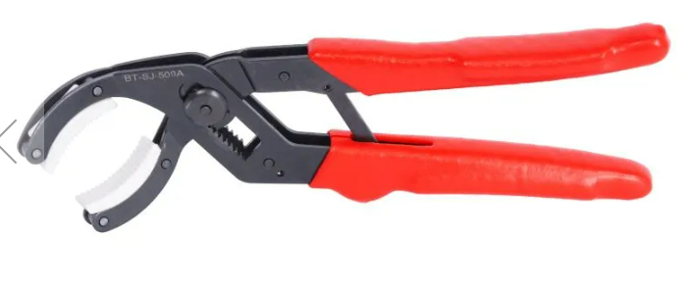
6. Daniels straight head [BT-SJ-509R](https://dmctools.com/mini-soft-jaw-pliers-straight-head) **$84.21** same as Snap-On?
   1. 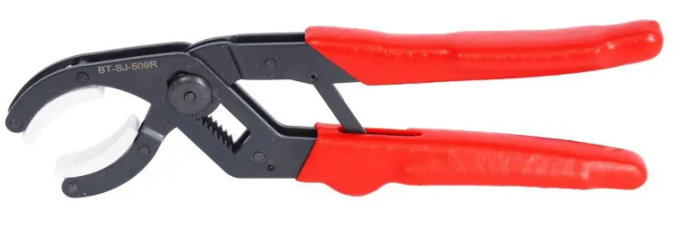
7. Knipex 81 11 250 **$44.00** ish – [amazon?](https://www.amazon.com/KNIPEX-Gripping-Replaceable-Plastic-8111250/dp/B01I20T9I8?th=1)
   1. 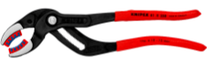
8. Knipex 81 01 250 **$35.35**
   1. 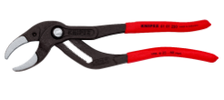
9. Stanley J253G **$33.86** amazon
   1. 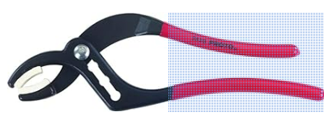
10. SK tools 7625 **$75.00** amazon
    1. 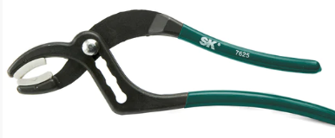

# Terminal activation tools

1. Pheonx contact [1200135](https://www.digikey.com/en/products/detail/phoenix-contact/1200135/6163337) **$24.00**
   1. 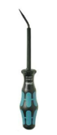
2. Wago [210-719](https://www.digikey.com/en/products/detail/wago-corporation/210-719/13549325) BLADE: 2.5 X 0.4 **$10.00**
   1. 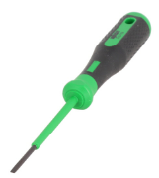
3. Wago [210-720](https://www.digikey.com/en/products/detail/wago-corporation/210-720/13549418) BLADE: 3.5 X 0.5 **$11.00**
   1. 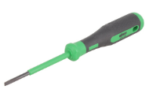
4. Wago [210-721](https://www.digikey.com/en/products/detail/wago-corporation/210-721/13549313)BLADE: 5.5 X 0.8 **$18.15**
   1. 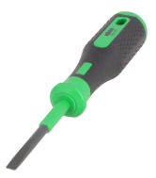
5. Wago [210-722](https://www.digikey.com/en/products/detail/wago-corporation/210-722/13549336) tool set **$36.47**
   1. 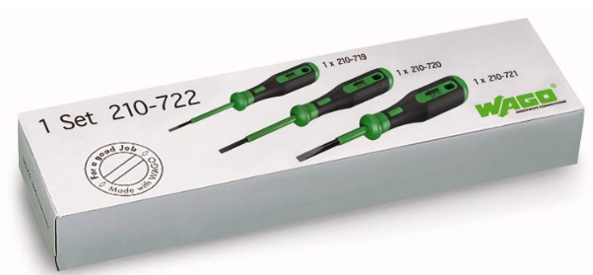
6. Wago [210-658](https://www.digikey.com/en/products/detail/wago-corporation/210-658/13549492) BLADE: 3.5 X 0.5 **$11.00**
   1. 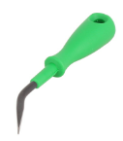
7. Wago [210-648](https://www.digikey.com/en/products/detail/wago-corporation/210-648/13549391)   BLADE: 2.5 X 0.4 **$11.00**
   1. 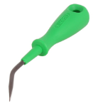
8. Wago [210-657](https://www.digikey.com/en/products/detail/wago-corporation/210-657/13549332) BLADE: 3.5 X 0.5 **$10.00**
   1. 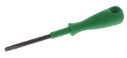

## Tool kits

Veam manufacturer tool kit. This is what I recommend

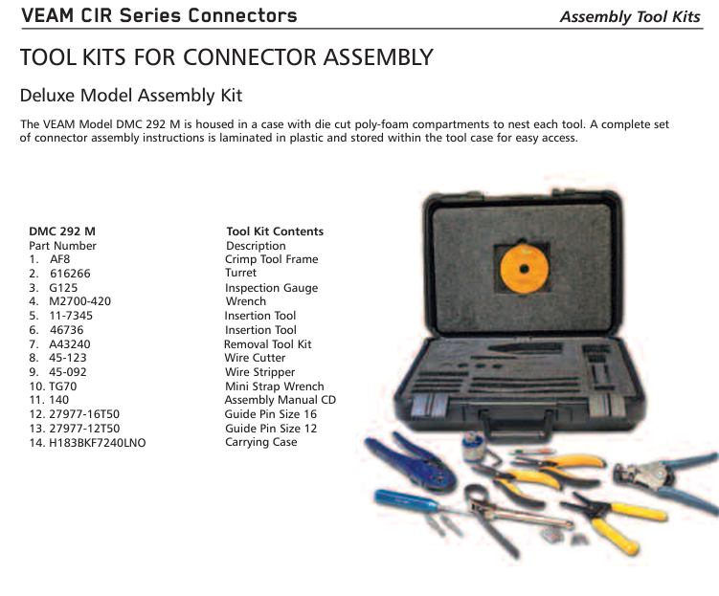

Maybe we should contact Daniels to assemble a generic tool kit?

<https://dmctools.com/products/tool-kits>

